Name_________________________________ Period _____________ Date ________________



**Lesson 3: Reading Electric Meters**

The amount of electricity that a household uses is measured by an electric meter. Some electric meters are digital and read like a car odometer, but the rest are analog meters with dials. Can you read an analog electric meter?

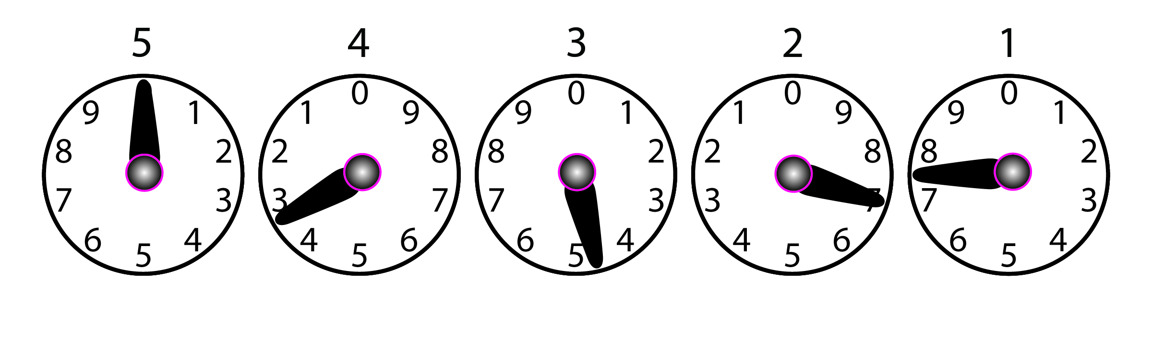

**Doing the Science**

1. Read all of the dials from right to left. Note that dials 1, 3 and 5 turn clockwise and dials 2 and 4 turn counterclockwise.
2. If the hand is between two numbers, read the smaller number.
3. If the pointer is exactly on a number, record the next lowest number unless the dial on the right has passed zero. (For dial 1, this does not apply.)
4. Use these rules to read the sample meter above. Record your answer in Table 1.
5. Reading the numbers in the table from left to right, record the meter reading below Table 1.

**Table 1.**

|  |  |  |  |  |
| --- | --- | --- | --- | --- |
| **Dial 5** | **Dial 4** | **Dial 3** | **Dial 2** | **Dial 1** |
|  |  |  |  |  |

Reading: __________ kWh

**Do You Understand?**

1. What is the reading of the meter below?

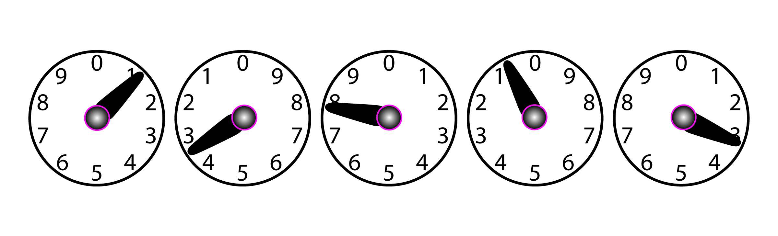

Reading: __________ kWh

1. What is the reading of the meter below?

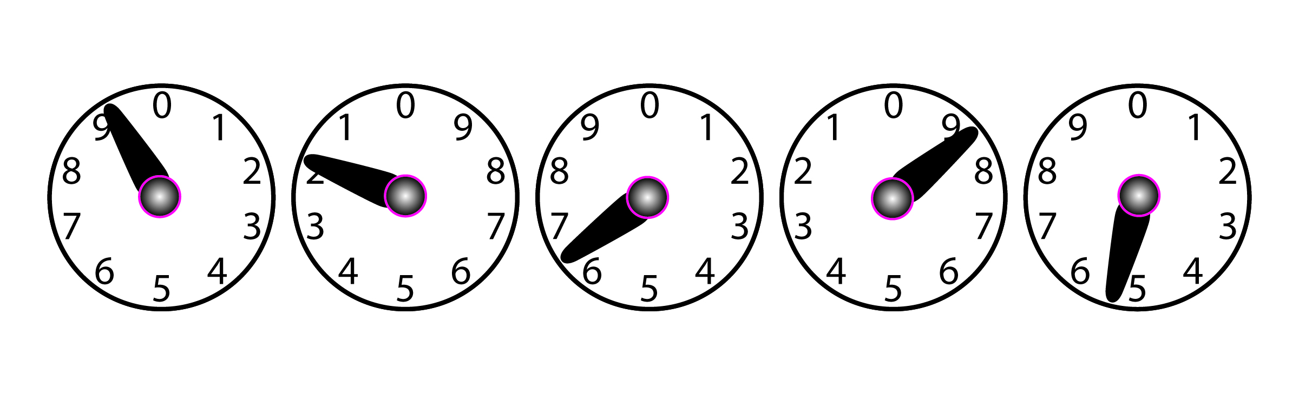

Reading: __________ kWh